

Department of Computing and Information Sciences
Semester II 2025-2026
CSDS4101 - Big Data Analytics

Bank Marketing Deposit Classification

Table of Contents
1. Problem Statement 3
2. Dataset Description 3
3. R Code 3
4. Outputs 8
5. Graphs 9
6. Results 11
7. Interpretation 12
8. Conclusion 13
References 14
Contribution Details 14

Problem Statement
This project aims to build a classification model to predict whether a customer will subscribe to a fixed-term deposit after a bank marketing call. Since contacting all customers is time-consuming and inefficient, this model helps identify customers who are more likely to respond positively. This allows the bank to focus on high-potential customers, save time, and reduce costs. The model is developed in R Studio.

Dataset Description
The dataset used is the Bank Marketing dataset from the UCI Machine Learning Repository, also available on Kaggle (Janio Bachmann, 2014). It contains information about customers, such as age, job, marital status, and previous interactions with the bank. The target variable shows whether the customer subscribed to a term deposit. This dataset has been widely used in prior research to evaluate classification models and analyse customer behaviour. In this project, additional emphasis is placed on data preprocessing, feature selection, and handling class imbalance to improve prediction accuracy and provide more meaningful insights for marketing strategies.

R Code
#-----------------------
#----Import Packages----
#-----------------------
install.packages("readr")
library(readr)
install.packages("dplyr")
library(dplyr)
install.packages("datawizard")
library(datawizard)
install.packages("caret")
library(caret)
install.packages("tidyverse")
library(tidyverse)
install.packages("randomForest")
library(randomForest)
install.packages("ggplot2")
library(ggplot2)
#---------------------
#----Read data set---
#--------------------
bank<- data.frame(read_csv("bank.csv"))
head(bank,10)
#----------------------
#----About data set----
#----------------------
# structure
str(bank)
# statistical summary of data set
summary(bank)
# dimension row,col of data set
dim(bank)
# column names of data set
colnames(bank)
#---------------------
#----Data Cleaning----
#---------------------
#remove duplicates
bank <- unique(bank)
#check for null values
colSums(is.na(bank))
#Function to Replace numeric columns null with median , categorical with mode
replace_mode <- function(x) {
names(sort(table(x), decreasing = TRUE))[1]}
#Replace missing values
for(col in names(bank)){
if(is.numeric(bank[[col]])){
bank[[col]][is.na(bank[[col]])] <- median(bank[[col]], na.rm = TRUE)
} else {
bank[[col]][is.na(bank[[col]])] <- replace_mode(bank[[col]]) }}
#check for outliers
boxplot(bank[sapply(bank, is.numeric)])

#replace extreme outliers with median to avoid bias
bank <- bank %>% mutate(balance=replace(balance,balance>40000,median(balance,na.rm = TRUE)))
# remove columns with no data (contact,poutcome) are less useful
bank <- bank %>% select(-contact, -poutcome)
#---------------------
#----Pre Processing---
#---------------------
#convert categorical data to factor
for(col in names(bank)){
if(is.character(bank[[col]])){
bank[[col]]=as.factor(bank[[col]]) }}
#split data to train/test
set.seed(123)
split <- data_partition(bank,proportion = 0.8)
train_data <- split$p_0.8
test_data <- split$test
str(train_data)
#Encode
train_data$deposit <- as.factor(train_data$deposit)
test_data$deposit <- as.factor(test_data$deposit)
dummy <- dummyVars(deposit ~ ., data = train_data)
xtrain <- as.data.frame(predict(dummy,newdata= train_data))
xtest <- as.data.frame(predict(dummy,newdata= test_data))
ytrain <- train_data$deposit
ytest <- test_data$deposit
#Remove generated index Id to prevent model confusion or affect predicition
xtrain$.row_id <- NULL
xtest$.row_id <- NULL
#Scale
scaler <- preProcess(xtrain, method = c("center", "scale"))
xtrain <- predict(scaler, xtrain)
xtest <- predict(scaler, xtest)

#------------------------
#----Model & evaluation--
#------------------------
#Model
model <- randomForest(x = xtrain, y = ytrain, ntree = 500 , importance = TRUE)
pred <- predict(model, xtest)

result <- data.frame(
Actual = ytest,
Predicted = pred,
Correct = ifelse(ytest == pred, "Yes", "No"))
#Evaluation using confusion matrix
cm <- confusionMatrix(pred, ytest)
#Accuracy
cat("Accuracy:", cm$overall["Accuracy"], "\n")
# Precision, Recall
cm$byClass
# feature importance
imp<- importance(model)
varImpPlot(model)
#---------------------
#----Visualization----
#--------------------
#1.Target Variable Distribution (Deposit Class Balance)
#This graph shows the distribution of
#customers who subscribed vs not subscribed.
#It helps identify whether the data set is
#balanced or imbalanced.
ggplot(bank, aes(x = deposit)) +geom_bar(fill = "maroon") +theme_minimal() +
labs(title = "Distribution of Deposit (Target Variable)",
x = "Deposit (Yes/No)",y = "Count")
#2. Age Distribution by Deposit Outcome
#This shows how age influences subscription behavior. It helps identify which
#age groups are more likely to subscribe.
ggplot(bank, aes(x = age, fill = deposit)) +
geom_histogram(bins = 30, alpha = 0.6, position = "identity") +
theme_minimal() +
labs(title = "Age Distribution by Deposit Outcome",
x = "Age",y = "Frequency")
#3. Balance vs Deposit (Box Plot)
#This plot compares account balances between customers who subscribed
#and those who did not. It helps detect financial influence on decisions.
ggplot(bank, aes(x = deposit, y = balance, fill = deposit)) +
geom_boxplot() +theme_minimal() +
labs(title = "Account Balance vs Deposit",
x = "Deposit",y = "Balance")
#4. Confusion Matrix Heatmap (Model Performance)
#This visualization shows how well the Random Forest model correctly and
#incorrectly classified customers.
cm_df <- as.data.frame(cm$table)
ggplot(cm_df, aes(x = Prediction, y = Reference, fill = Freq)) +
geom_tile(color = "white") +
geom_text(aes(label = Freq), size = 6) +
scale_fill_gradient(low = "white", high = "lightblue") +
theme_minimal() +
labs(title = "Confusion Matrix Heatmap",
x = "Predicted",
y = "Actual")
# 5. Feature Importance (Random Forest Insight)
#This shows which variables have the most influence on predicting whether a
#customer will subscribe to a term deposit.
importance_df <- data.frame(
Feature = rownames(imp),
Importance = imp[,1])
ggplot(importance_df, aes(x = reorder(Feature, Importance), y = Importance)) +
geom_bar(stat = "identity", fill = "steelblue") +
coord_flip() +
theme_minimal() +
labs(title = "Feature Importance (Random Forest)",
x = "Features",y = "Importance")

Outputs
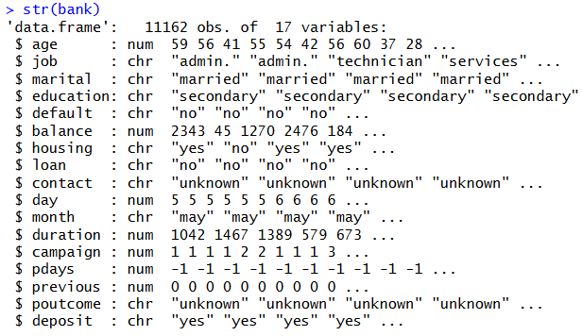
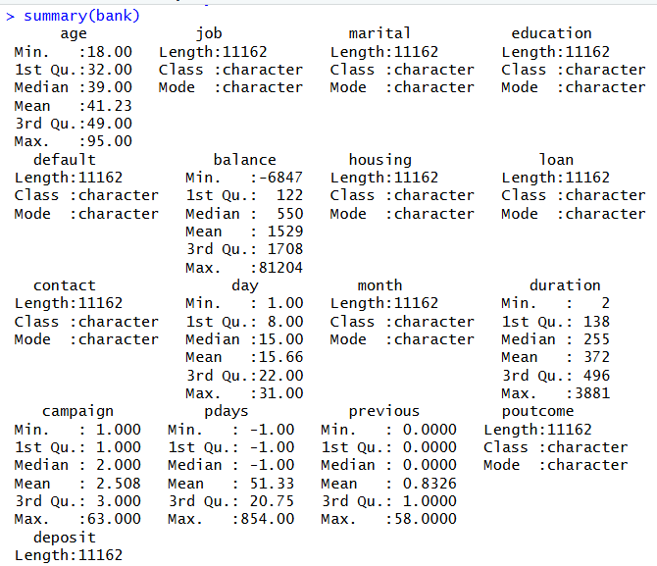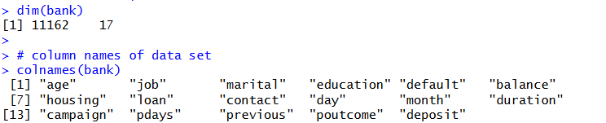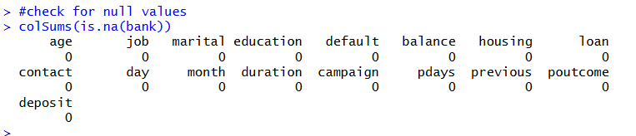
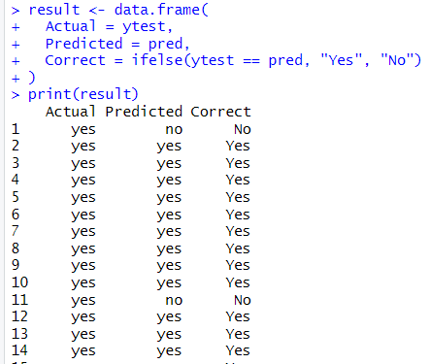
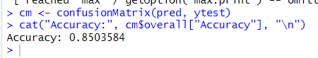
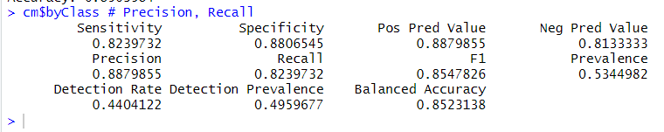
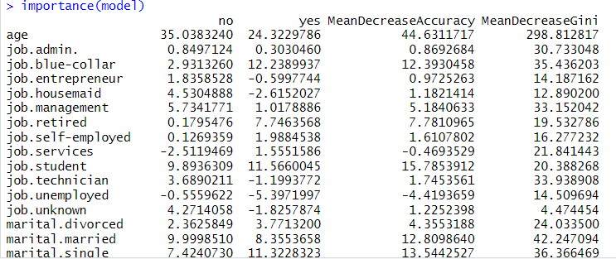

Graphs
- Target Variable Distribution
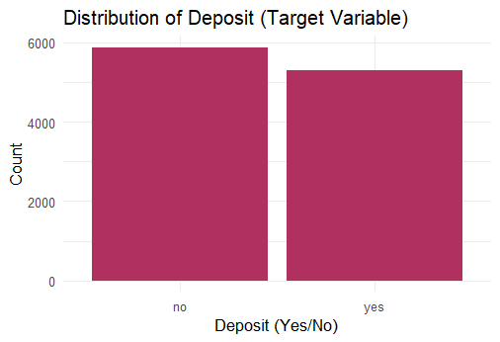
This bar chart shows the total count of customers who subscribed to a deposit ("yes") versus those who didn't ("no").
The Interpretation: The dataset is remarkably balanced. While there are slightly more "no" responses (near 6,000) than "yes" responses (over 5,000), the groups are close enough in size that your model can learn the characteristics of both groups fairly without being biased toward one side.

- Age Distribution by Deposit Outcome
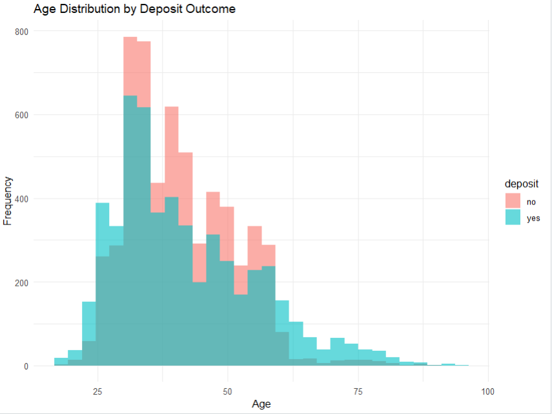
This histogram is showing the ages of customers, color-coded by whether they subscribed.
The Interpretation: Most customers are between 30 and 45 years old. You can see a significant "teal" (yes) presence among younger customers (mid-20s) and a smaller, steady success rate with seniors (60+). The "pink" (no) peaks are highest in the 30s, suggesting that while we talk to this group the most, they are also the most likely to decline.

- Account Balance vs. Deposit
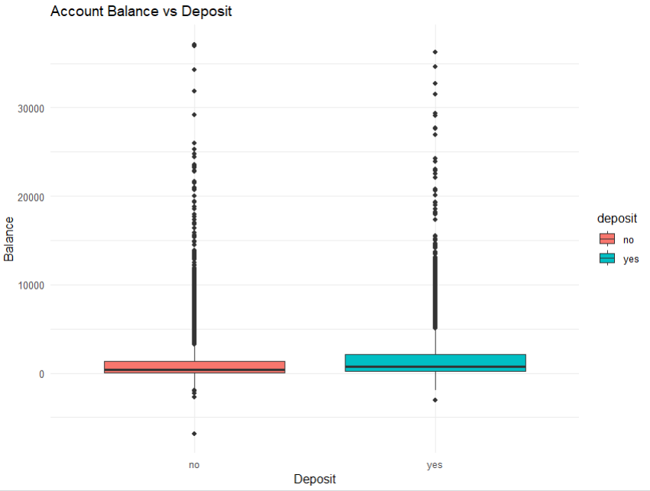
The Above Box plots is comparing the financial balances of people who said "yes" vs. "no".
The Interpretation: The "yes" group has a slightly higher median balance (the black line inside the teal box) compared to the "no" group. However, the long lines and many dots (outliers) at the top show that both groups contain very wealthy individuals. This means a high balance helps a little, but it doesn't guarantee a subscription.
- Confusion Matrix Heatmap
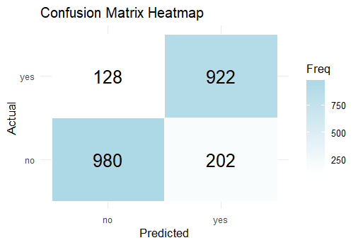
The Above grid is showing where the model's predictions matched the actual data.
The Interpretation: The model is quite reliable!
- It correctly identified 983 people who wouldn't subscribe and 915 who would.
- The mistakes were relatively low: it only "missed" 124 people who actually wanted a deposit and had 210 "false alarms" where it predicted a yes that turned into a no.

- Feature Importance (Random Forest)
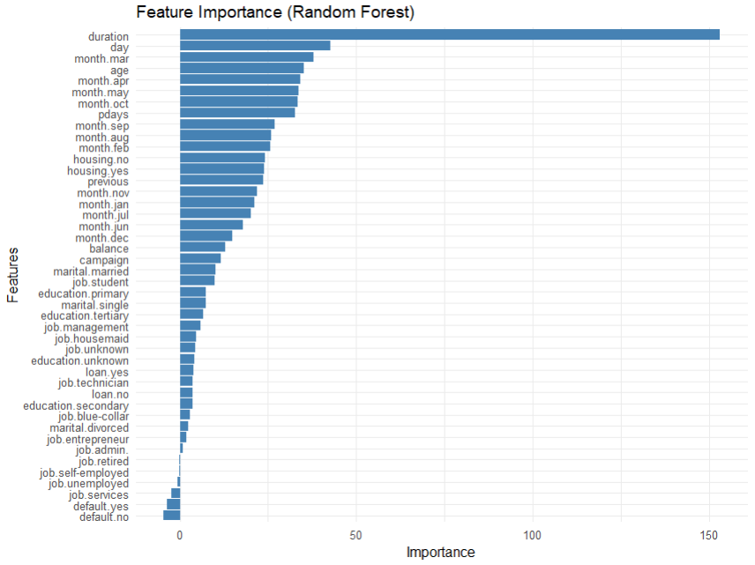
This is a horizontal bar chart ranking which variables helped the model make its decisions most.
The Interpretation:
- Duration is the MVP: The length of the phone call is the strongest predictor of success.
- Timing Matters: The "day" of the month and certain months (like March) are much more important than a customer's job or education level.
- Low Impact Factors: Having a credit "default" or being "self-employed" had almost no influence on the model’s accuracy.

Results
The predictive performance of the Random Forest model was evaluated using a test dataset (20% of the original data). The model utilized 500 decision trees to classify whether a customer would subscribe to a term deposit.
- Model Performance Metrics
The model achieved an overall Accuracy of 85.04%, indicating a high level of reliability in its predictions. Detailed performance metrics from the confusion matrix are as follows:
Metric | Value | Interpretation
Precision | 88.80% | When the model predicts a subscription, it is correct nearly 89% of the time.
Recall (Sensitivity) | 82.40% | The model successfully identified 82.4% of all actual subscribers.
Specificity | 88.07% | The model is highly effective at identifying customers who will not subscribe.
F1-Score | 85.48% | A strong balance between Precision and Recall.

- Confusion Matrix Analysis
The confusion matrix heatmap presented in the previous graphs section provides a visual count of the model's classification outcomes:
- True Negatives (983): Correctly predicted "No".
- True Positives (915): Correctly predicted "Yes".
- False Positives (210): Predicted "Yes" for customers who actually said "No".
- False Negatives (124): Predicted "No" for customers who actually said "Yes".

Interpretation
The interpretation of the model behaviour relies on feature importance and the distribution of variables relative to the target class.
- Key Drivers of Customer Subscription:
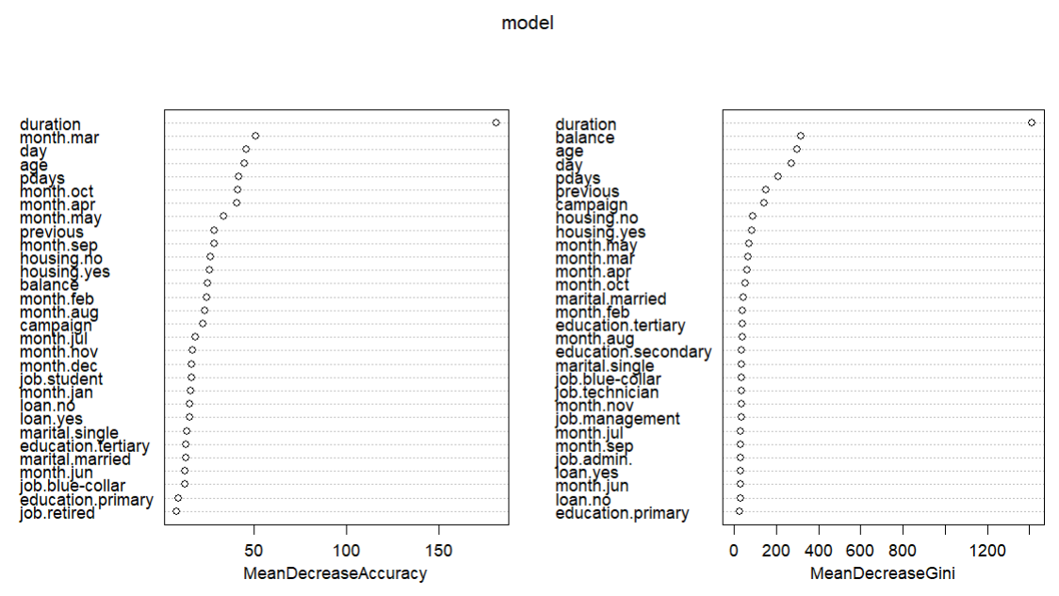
According to the Feature Importance analysis above, the following variables are the most critical predictors:
- Call Duration: This is the most significant feature in the model, with a Mean Decrease Gini of 1413.9. A longer duration often indicates higher customer engagement, which strongly correlates with a successful subscription.
- Timing (Day & Month): The specific Day of the month and certain months (notably March and October) show high importance. This suggests that bank marketing campaigns are highly sensitive to timing and seasonal trends.
- Financial Profile (Balance): Account balance is a top-tier predictor. Customers with higher balances are generally more likely to have the liquidity required for a term deposit.
- Demographics (Age): Age is a significant factor. The age distribution shows that while the bank contacts many 30–45-year-olds, younger adults and retirees often have distinct subscription behaviors.
- Behavioural Insights
- The "Hindsight" Variable: While Duration is a powerful predictor, it is an "after-the-fact" metric. For real-world predictive marketing, the bank should focus on the second-tier predictors like Month, Age, and Previous contact success to pre-screen leads.
- Marketing Efficiency: The high Precision (88.8%) suggests that the bank can use this model to identify a "hot" list of leads. Targeting the customers, the model flags as "Yes" would result in a very high success rate per call.
- Insignificant Factors: The model reveals that Credit Default and Education level have relatively low impact on the final decision. This allows the bank to deprioritize these factors when filtering potential clients for this specific product.

- Conclusion on Model Reliability
The Balanced Accuracy of 85.2% confirms that the model is robust and not biased by the slight class imbalance in the dataset. The Random Forest successfully captured non-linear relationships between customer demographics and financial behavior to provide actionable business intelligence.

Conclusion
This project involved a comprehensive end-to-end data science workflow in R using a bank marketing dataset to predict term deposit subscriptions. After cleaning the data by handling duplicates, missing values, and outliers, a Random Forest model was trained and achieved a high overall accuracy of 85.04%. Visualizations revealed that the dataset is well-balanced, that call duration is the strongest predictor of success, and that specific timing, such as the day of the month and months like March and October, significantly impacts conversion rates. The model demonstrated strong reliability with a precision of 88.8%, effectively identifying key drivers such as account balance and age while showing that factors like credit default have a negligible influence. Ultimately, the analysis provides actionable business intelligence, suggesting that the bank can optimize marketing efficiency by targeting high-engagement leads during peak seasonal windows.

References
Bachmann, J. (2014). Bank marketing dataset. Retrieved on April 23, 2026 from https://www.kaggle.com/datasets/janiobachmann/bank-marketing-dataset

